


BIGGA London Section and Oaklands College proudly presents the 2015 Greenkeeping Seminar

The 4 ‘V’s Seminar
(Vibration, Volunteering, Vision and Variations)

Date: Tuesday 17th February 2015, 9.30am – 2.50pm

Venue: Oaklands College – St Albans Campus
Hatfield Road St Albans AL4 0JA

Seminar Programme

9.30am – 10.15am: Arrival and parking

10.15am –Opening and introductions.

10.30am – 11.15am: Stella Rixon- (STRI) will be speaking on the subject of variations e.g. how things are changing in the greenkeeping world as changes in technologies and climate take effect.

11.15am – 12.00pm: John Ross – A Master Greenkeeper with over 20 years’ experience as a Course Manager and qualified Safety Consultant, will talk about vibration and noise at work and how compliance can be made simple. Coming from a greenkeeping background John will explain these difficult areas in a way that can be understood and then put into practice.

12.00pm – 12.55pm Lunch

1.00pm – 1.45pm: Steven Chappell- Steve will be talking on how volunteering led him on the path to the Ryder cup and the challenges involved in running one of the golfing world’s most prestigious events.

1.45pm- 2.30pm: Laurence Pithie- A Master Greenkeeper with a huge range of experience Laurence will be presenting on the importance of vision in golf course management.

2.30pm – 2.50pm: Acknowledgements and close.

There will be an opportunity to present questions to the speakers at the end of each talk.

Relevant attendees will earn 2 BIGGA CPD credits

Cost: £12.50 (inc. VAT) which must be paid in advance and includes lunch & refreshments.
To secure your place, please make cheques payable to Oaklands College and send to
Andrew Wight, Oaklands College St Albans Campus, Hatfield Road, St Albans, Herts, AL4 0JA.

For further information contact andy.wight@oaklands.ac.uk or call 01727 737735

Oaklands College/BIGGA 2015 Seminar Booking form

I would like to book ……… place/s on the Oaklands College Greenkeeping Seminar on Tuesday 17th February 2015

I enclose a cheque made payable to Oaklands College to the sum of £………………. (Cost per person is £12.50)

Important -Please note the seminar will take place at Oaklands College St Albans Campus (post code AL4 0JA) not at the Welwyn Garden City Campus where it was held last year. Parking is available on site.

Name/s of attendee/s

1. 5.

2. 6.

3. 7.

4. 8.

Company name

Address

Email address (please print carefully)

Phone Mobile

Return this slip with payment to

Andrew Wight
Head of Work Based Learning LBI
Oaklands College
St Albans Campus
Hatfield Road
St Albans
Herts
AL4 0JA

Travel to the St Albans Campus
Full address

Oaklands College St Albans Campus Hatfield Road St Albans Herts AL4 0JA

Note there is only one entrance and this is on the Hatfield Road (A1057) all other entrances (East drive and North drive on the map) are locked and do not carry vehicle traffic.

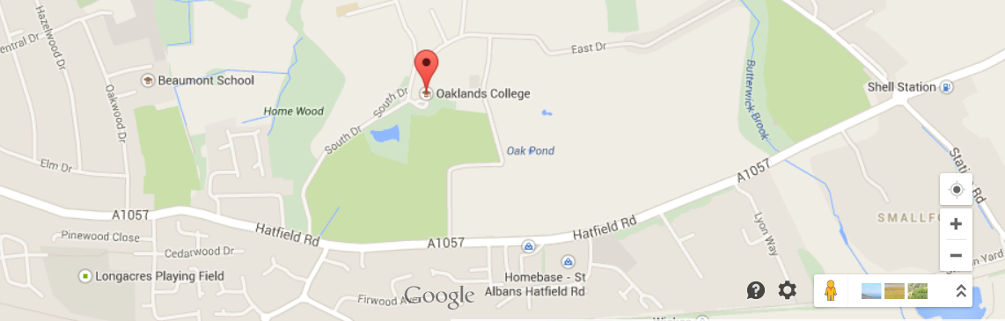

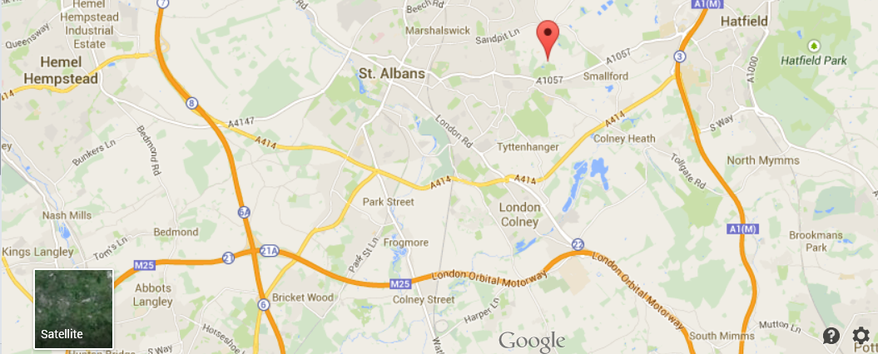

By Road

A1M Southbound - leave at junction 3 (just after end of tunnel) leave roundabout to A414 then right at end of 1st roundabout to Colney Heath Lane to mini roundabout then right to Hatfield Road and turn left then immediately right into entrance.

A1 Northbound - leave at junction 3 (1st junction before Galleria tunnel) roundabout to A414, right at end of 1st roundabout to Colney Heath Lane to mini roundabout then right to Hatfield Road turn left then immediately right into entrance.

M1 Southbound- leave at junction 8 to A414 at 3rd roundabout left to Colney Heath Lane to mini roundabout then right to Hatfield Road then turn left then immediately right into entrance

M25 clockwise - leave at junction 21A to 1st roundabout then left to North Orbital towards A414, join A414 then left at 3rd roundabout to Colney Heath Lane to mini roundabout then right to Hatfield Road and turn left then immediately right into entrance.

M25 Anticlockwise - leave at junction 23 to A1M north bound leave at junction 3 (1st junction before Galleria tunnel) at roundabout take A414 then right at end of 1st roundabout to Colney Heath Lane to mini roundabout then right to Hatfield Road, turn left then immediately right into entrance.

By train St Albans City station is 2 miles from the event and the college is on main bus route

