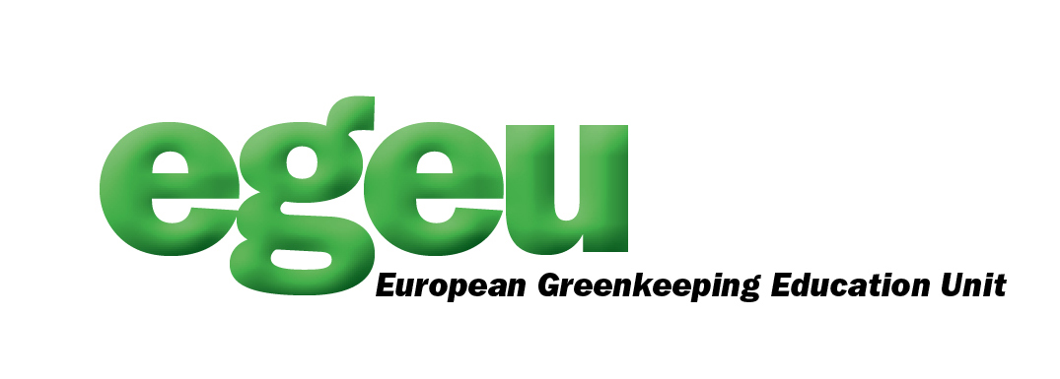
PRESS RELEASE

THE EUROPEAN GREENKEEPING EDUCATION UNIT (EGEU) is pleased to announce that a new website has been developed to complement the already existing EGEU website (www.egeu.eu)
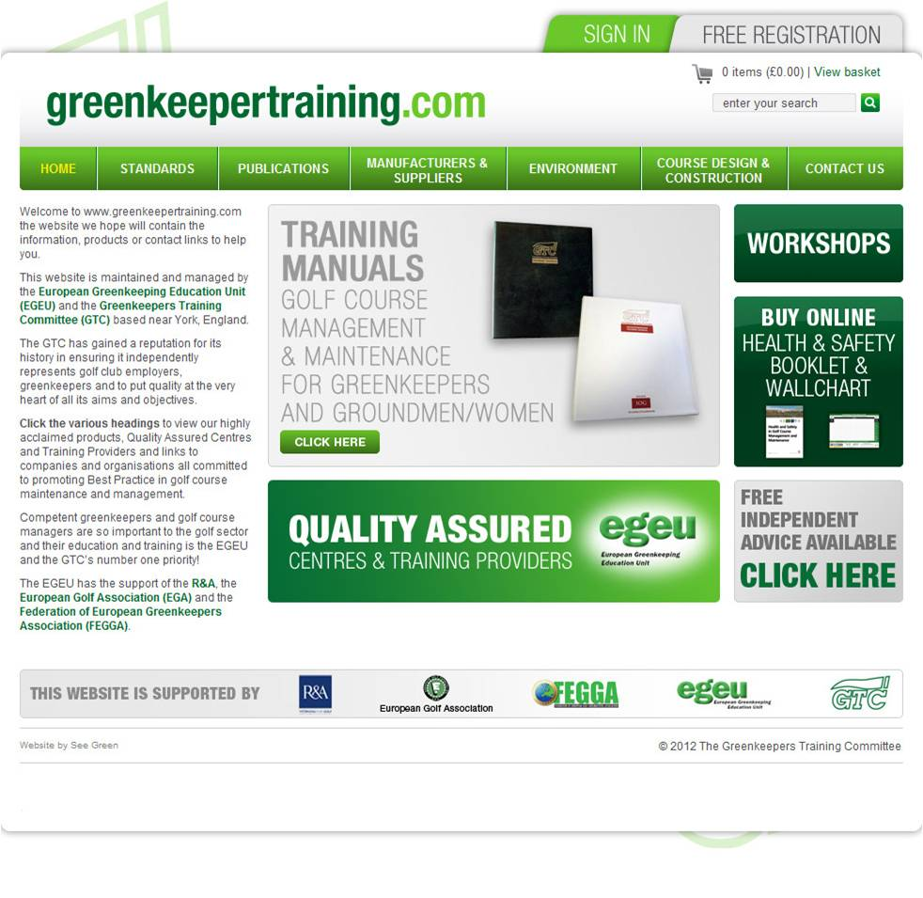
The new www.greenkeepertraining.com website, designed in association with The Greenkeepers Training Committee (GTC) and the Federation of Golf European Golf Greenkeeping Associations (FEGGA) is based on a Quality Assured Scheme of Centres and Specialist Training Providers all having met a criteria and available to offer both formal and bespoke training courses.

Employers and greenkeepers are encouraged to view the new website as there are courses and contacts available to assist with successful staff and management development.

David Golding, a Director of the EGEU and the GTC’s Education Director believes the new website will develop into the independent information portal for the sector as more countries look to establish a greenkeeping education and training structure to allow access to learning for all levels of operatives and managers.

Any Centre, college, companies or individual involved in delivering greenkeeper education and training based on Best Practice are encouraged to apply to become involved in the Quality Assured accreditation Scheme.

David added, advice and guidance will be available to help grow the game globally using expertise in all subject areas to ensure best practices are used to maintain and mange a golf clubs greatest asset, the golf course.

To register visit: www.greenkeepertraining.com

For further information on the website or EGEU please contact:

David Golding, Standards and Quality Assurance Director: davidgolding@egeu.eu
Tel: +44 (0) 1347 838640

Dean Cleaver, Sales and Marketing Director: deancleaver@egeu.eu
Tel: +44 (0) 1789 762912

John Holliday, Finance Director: johnholliday@egeu.eu
Tel: +44 (0) 1729 822130

