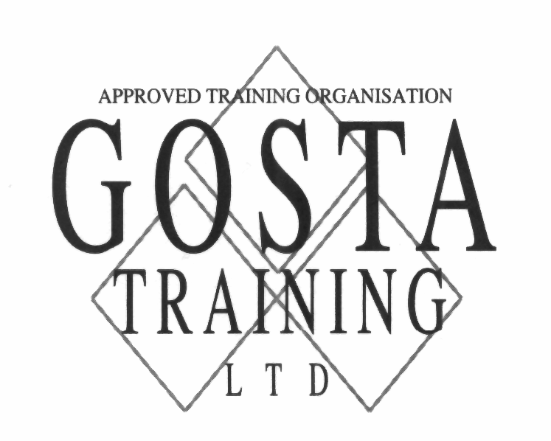
50 Brook Street, Glasgow, G40 2AB
Telephone No. 0141-556-3999 e-mail: learn @gostatraining.co.uk

GOSTA Training, based in Glasgow has secured a contract with Skills Development Scotland (SDS) to deliver apprenticeships to the Sports Turf sector.

GOSTA has an excellent record of apprenticeship achievements including the Lantra Apprentice of the Year winner Paul Carella, in 2008.

The apprenticeship programme is designed to suit the apprentice and their employer with flexibility the feature of GOSTA’s delivery.

Lesley Lowrie, GOSTA Training’s Managing Director is delighted with the new contract and hopes that golf club and sports grounds employers will take advantage of this opportunity to have an apprentice educated and trained through a Government support funded scheme.

Lesley added, there has been much talk about the economic climate and as a company we sincerely look forward to assisting any employer looking to invest in staff development.

David Golding, Education Director to The Greenkeepers Training Committee (GTC) adds, GOSTA Training is one of only two GTC Quality Assured Centres in Scotland and believes demand for these new apprenticeships from employers will prove that even during difficult times for many golf clubs staff training is still of the highest priority to ensure standards are maintained and the business develops successfully.

For further information on apprenticeships through GOSTA Training:

Telephone: 0141 556 3999 or email learn@gostatraining.co.uk
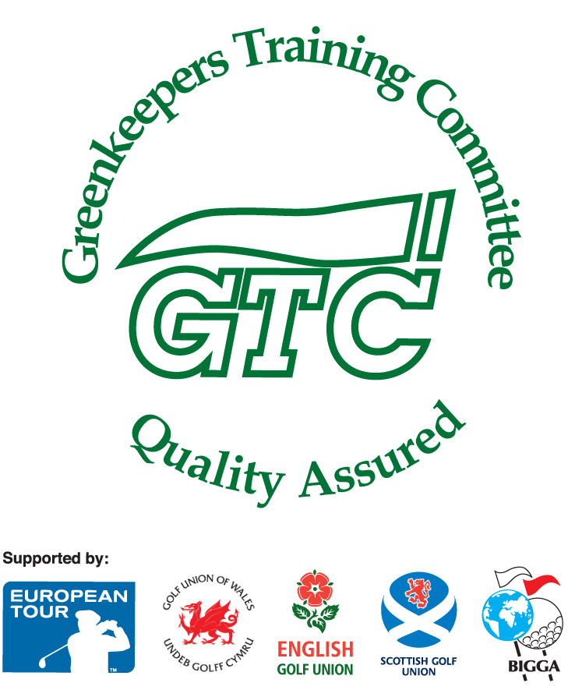




Directors: L.L.Lowrie (Managing & Secretary), G.R. Lowrie
Registered Office: 50 Brook Street, Glasgow, G40 2AB. Reg.No.80277 Scotland

