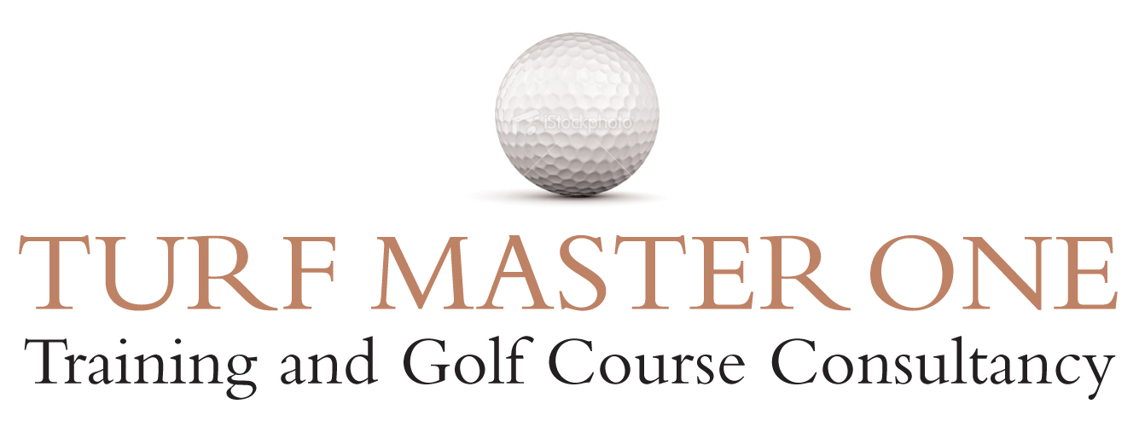

GOLF COURSE MANAGEMENT - Laurence W. Pithie MG

9am – 9.30am Registration Tea, coffee and biscuits on arrival

ONE- DAY WORKSHOP SUMMARY: The day will be divided into 5 main & interactive sections

SECTION 1 - Introduction & The Role & Responsibility of the Chairman of Green
The requirements of a Chairman of Green, the role to play and the responsibilities involved.
A Course Manager’s key areas of responsibility

SECTION 2 - UK Perspective: Environment & Climate
Soil type
Drainage
Grass types
The Environment & the effects on turf quality
An overview of the UK in terms of latitude, rainfall, temperature & natural vegetation and how this impacts golf course management, key aspects of soil types and drainage and an in-depth look at the varying grass species, particularly on greens. The section also makes recommendations of the steps that can and should be taken to provide greater sustainability.

SECTION 3 - Basic Fundamentals in Managing Fine Turf
The Soil
Plant Growth
4 Main Building Blocks
A broad understanding of the soil and plant growth and how they affect golf course playability. This section also deals with the 4 main building blocks necessary for managed turf.

SECTION 4 - Cultural Practices & their Benefits
Aerification
Scarification
Top Dressing
Over-seeding
Each of the 4 key cultural practices are explained in detail along with the various methods and types of equipment used and why they are necessary when dealing with typical problems such as thatch control, compaction and over-coming weak or thinly covered areas of turf.

SECTION 5 - Course Conditioning & Presentation
Overview & Fundamentals
Key Areas: Greens, Tees, Fairways etc
Bringing it all together
The key aspects and fundamentals in developing a course conditioning strategy. Other areas discussed are surrounds, roughs, bunkers, club surrounds & water features.

SUMMARY
A summary of the workshop and the information gained. Hand-outs available for all delegates

4pm approx Finish

Laurence W Pithie MG Turf Master One is a GTC Quality Assured Training Provider
Turf Master One Ltd
www.turfmasterone.co.uk
07774 414207

