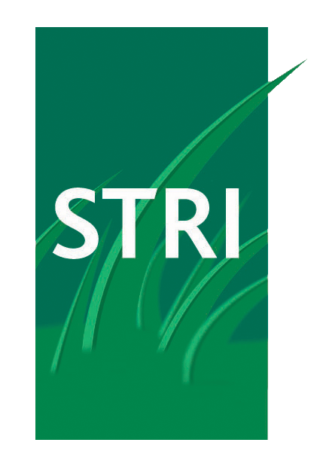

8 March 2013
STRI TRIUMPH AT BRITISH EXPERTISE INTERNATIONAL AWARDS
STRI, the world’s leading sports turf consultancy, has scooped the Outstanding International Business Award (SME) prize for their pitch construction work in Ukraine at the British Expertise International Awards 2012/13.
Crowned overall winner in the Outstanding International Business Award category, STRI was recognised for their pitch improvement installation at four stadiums in Ukraine in the lead up to EURO 2012.
The accolade is specifically in recognition of the largest development project undertaken in Kharkiv where STRI overcame a number of operational problems including customs delays and severe weather.
An innovative pitch ventilation and vacuum system developed by STRI, (ISASS: In Situ Air Sparging System) was utilised in order to undertake the installation of a world class playing surface within a five week period. A legacy framework programme for the ongoing maintenance was also successfully implemented.
STRI, who are the official pitch consultants for FIFA and UEFA, designed and managed the project at the 39,000 capacity FC Metalist stadium in conjunction with Clive Richardson Limited, Engo Limited, and Desso Limited.
Held annually to recognise and celebrate outstanding international achievements by companies in the UK professional services sector, The Outstanding International Business Award (SME) accolade was received by STRI at a celebration dinner at The Cumberland Hotel, London.
The British Expertise International Awards were attended by a number of distinguished guests including HRH The Duke of Gloucester and Lord Marland, Prime Minister’s Trade Envoy who delivered a keynote address at the event.
Gordon McKillop, STRI’s Chief Executive said: “It’s fantastic news for STRI to receive this acknowledgement amongst an array of distinguished organisations making a notable impact in export markets. And we’re delighted to receive recognition for the work we’ve undertaken in Ukraine, particularly Kharkiv.
“A number of challenges were overcome to deliver a first class pitch in a country widely regarded as one of the most difficult to work in. This accolade is testament to the hard work and dedication of our team of turf professionals as well as the team work of the consortium of organisations involved. This award will further enhance our reputation in the turf management industry for delivering world class playing surfaces both domestically and around the world.”

-ENDS-
For more information, please contact Terry Gilligan at Good Relations Regional on 0113 237 2835 / 07770 703541 or tgilligan@goodrelationsregional.co.uk

About STRI
STRI (previously Sports Turf Research Institute) is one of the world’s leading authorities on turfgrass, providing advice and expertise on the research, design, construction and management of both natural and artificial sports surfaces.
STRI was established in 1929, in association with the UK Golf Unions and The R&A (Royal and Ancient Golf Club of St Andrews), to provide research and advisory services for golf clubs on their golf greens and courses.
By the 1950s, STRI had established their reputation as the leading company for providing advice and research on new products and techniques for managing sports turf, not just for golf, but for all types of sports surfaces and amenity grass areas.
The last two decades have seen rapid growth within STRI, currently with 75 staff, delivering a range of consultancy and research services across an international client base of around 2,100 sports clubs and facilities each year.
STRI’s clients include sports governing bodies, stadium architects and contractors, sports club owners and facilities managers, local authorities and schools.
Current and recent STRI clients include:
Football: FIFA 2014 Brazil, UEFA for EURO 2012 & 2016 stadia and training pitches, LOCOG (Olympics 2012), Gamla Ullevi Stadium in Gothenburg, Spartak Stadium in Moscow
Golf: all nine Open Championship courses, The R&A
Equestrian: LOCOG (Olympics 2012), Ascot, Cheltenham, Hickstead Arena, Royal Dublin Showground
Tennis: Wimbledon
Rugby: Murrayfield, Millennium, Twickenham, Aviva
Gaelic: Croke Park, Semple Stadium
Cricket: Headingley, Lords
Research: FIFA, The R&A, ECB, Syngenta, Everris, Bayer, Aquatrols, BASF, DLF-Trifolium
The company’s website at www.stri.co.uk contains more information on STRI and their range of services.

